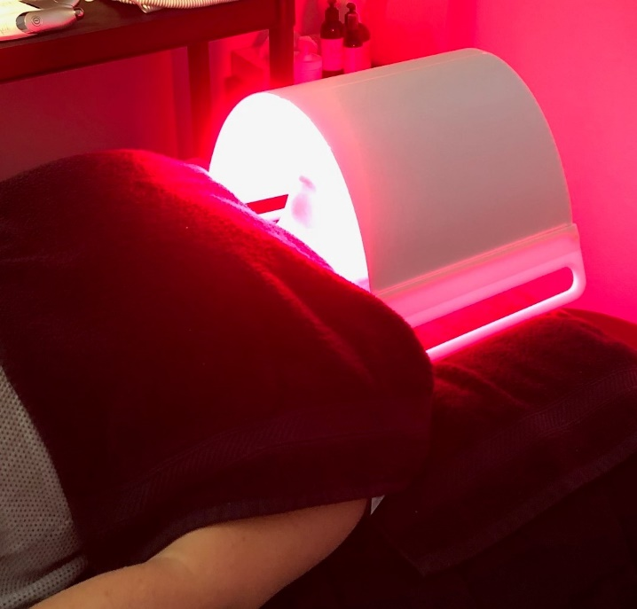
Illuminate Your Complexion
Visible red light, at a wavelength of 650nm (nanometers), penetrates human tissue to a depth of 8-10 mm. Skin layers, because of their high blood and water content, absorb red light very readily. The light affects a group of cells at the cellular level. The light causes these cells to release other cellular products. These products have the effect of dilating (opening up) skin capillary blood vessels. The dilation of these blood vessels leads to an increase in the blood flow. An increase in blood flow carries oxygen and nutrients to the skin. Light therapy restores skins natural cellular activity and promotes tissue regeneration.
LEDs do not deliver enough power to damage the tissue, but do deliver enough energy to stimulate a response from the body to heal itself. Aside from the great results, the best news is that Light Therapy has no reported side effects. LED is an FDA approved Therapy.

What Does Light Therapy Do?
*Increases circulation *Stimulates the production of collagen *Helps to heal wounds *Protects healthy skin *Helps to repair damaged skin *Decreases pore size *Useful in skin rejuvenation *Increases RNA and DNA synthesis, helping damaged cells to replace more promptly *Stimulates fibroblastic activity *Increases lymphatic system activity *Kills bacteria that causes acne *Comforts sore muscles, aches and pains *Increases moisture retention *Firms skin *Increases oxygenation and restoration of skin’s natural cellular activity, which keeps the skin renewed and fresh.

Insert Your Info Here

