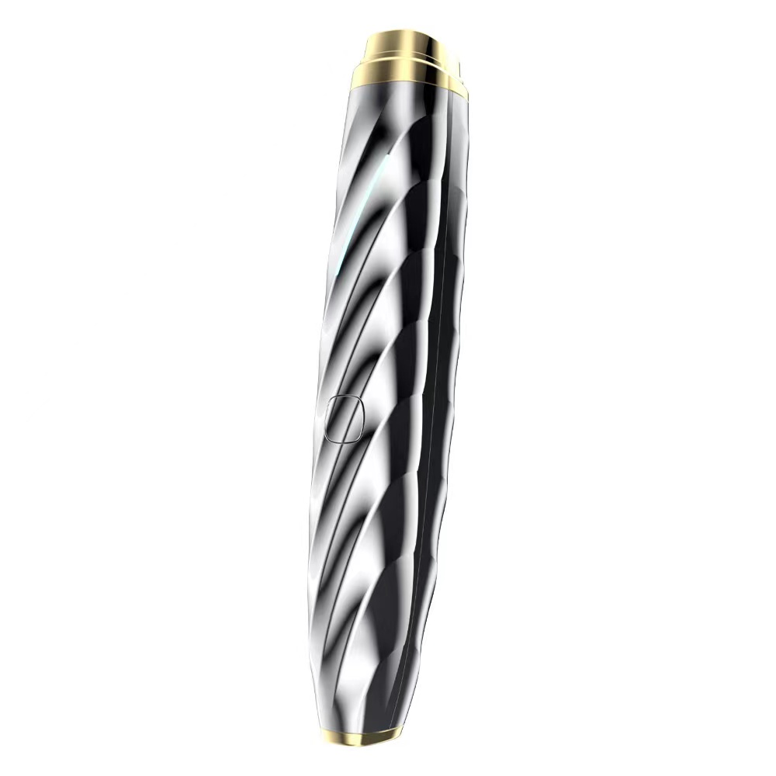

The Eye & Lip Enhancer
USER MANUAL PLEASE READ CAREFULLY

Thank you for purchasing the Eye & Lip Enhancer. This home use tool utilizes radio frequency, nanocurrent technology, red light (620nm-630nm) and biomechanical vibration to help smooth fine lines around the eyes & lips and diminish dark circles & puffiness under the eyes. It may tighten the skin around the eyes to create a brighter look. This tool helps to better penetrate products for more hydrated skin.

Important
Before using the Enhancer tool, please read this user manual carefully and keep it for future reference.
Do not use the instrument for any other purpose than described in this manual.
It is recommended to charge, use, and store the instrument at temperatures between 5℃/40°F and 35℃/95°F.
If your skin is still recovering from a medical cosmetic procedure such as having had a deep chemical peel, dermabrasion, laser resurfacing, fractional laser treatments, or facelift within the past 2 weeks, DO NOT use the tool. Get Physician clearance before using.
Wait 10 days after Botox or Fillers to use the Eye & Lip Enhancer.
Radio Frequency creates heat. If you are sensitive to heat do not use the Eye & Lip Enhancer.

Contraindications and other warnings
If you have medical concerns, consult a dermatologist before using.
Do not use the Enhancer if you are sensitive to light.
Do not use the Enhancer if you have open wounds, severe acne, sunburned skin, or an infection.
Do not use directly on the eyeball area. The upper eye lid is fine.
Do not use the Enhancer over irritated skin.
Do not use it more than once a one day in the same area. Excessive use may cause skin burns or damage.
Do not share your instrument with others without sanitizing it as this may lead to cross-contamination of bacteria and harmful infections.
Do not use it if pregnant or have a pacemaker.

General Information
Regular cleaning of the tool ensures better performance and a longer lifespan.
If there is product residue left on the tip of the tool, it may continue to operate without touching the skin. After cleaning the tool, it will stop operating.
Keep the charging cable dry. Do not immerse the tool in water.
To charge the tool only use the charging cable supplied.
Do not continue to use the tool if the charging cable appears damaged.
Fully charge the tool at least every 2 months to preserve battery life. When not in use do not leave plugged in.
This tool is not intended for use by children under 12 years of age, or by persons with reduced physical, sensory, or mental capabilities, or lack of experience and knowledge, unless they have been supervised or instructed in use of the tool by a person responsible for their safety.
Do not use the tool if it is visibly damaged. Do not attempt to disassemble or repair it. Doing so could cause further damage, which will result in the warranty being voided.
Specifications:
Adapter 5V 1A Charging Complete in 2 Hours
RF: 1Mhz
Red Light: 620nm-630nm
EMS: 10μA
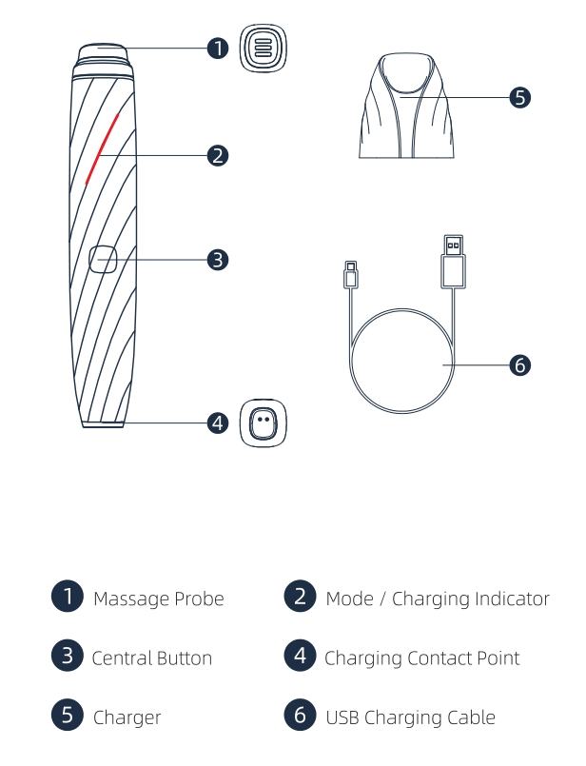

Function Guide
1.The Eye & Lip Enhancer consists of three modes: The first is Radio Frequency and LED (red light on base of unit). The second is Radio Frequency (RF), Nanocurrent and LED (blue light on base of unit). The third is Radio Frequency (RF), Nanocurrent, Biomechanical vibration and LED (violet light on base of unit).
2. Press and hold the button to turn on the tool. A quick press will switch to the next mode.
3. Press and hold the button to power off.
4. The tool will automatically shut off after 10 minutes.

Radio Frequency Warning: The radio waves generated by radio frequency heat the lower levels of the skin. You will feel warmth, the hotter temperature is penetrating deeper. Please keep the tool moving on the skin. Do not hold it in one area for longer than 2 seconds.

Mode One: RF and LED
The radio waves generated by the tool enter the subcutaneous tissue to generate heat energy. It uses the principle that the collagen fibers of the dermis will shrink at 55-70°C. It has two effects: firming the skin and promoting collagen regeneration. When the collagen produces immediate contraction, it will also stimulate the dermis to secrete more new collagen fibers to regenerate, thereby increasing the thickness and density of the dermis and smoothing wrinkles.
The use of specific wavelength red light can improve the micro-circulation of the blood system and lymphatic system of the skin, it stimulates the activity of mitochondria in cells. The red light stimulates fibroblast to speed up production of collagen, it activates blood circulation which improves wrinkles and moisturizes the skin from the inside.

How to use:
Step 1: Press and hold the central button to turn on the tool. It will default to mode one with a red-light indicator on the tool.
Step 2: Apply skin care products to the area around eyes or lips. Move slowly for 1 to 2 minutes. See video.

Mode Two: Nanocurrent (EMS) and LED
EMS is a slow-release current to revitalize facial muscles and promote local blood circulation which activates lifting and tightening skin.
The use of specific wavelength red light can improve the micro-circulation of the blood system and lymphatic system of the skin, it stimulates the activity of mitochondria in cells. The red light stimulates fibroblast to speed up production of collagen, it activates blood circulation which improves wrinkles and moisturizes the skin from the inside.

How to use:
Step 1: Press and hold the central button to turn on the tool. It will default to mode one with a red-light indicator the base. Press button quickly for mode 2 with a blue light indicator on the tool.

Step 2: Apply skin care products to the area around eyes or lips. Move slowly for 1 to 2 minutes. See video.

Mode Three: Radio Frequency (RF), Nanocurrent (EMS) Biomechanical Vibration & LED
The radio waves generated by the tool enter the subcutaneous tissue to generate heat energy. It has two effects: firming the skin and promoting collagen regeneration. When the collagen produces immediate contraction, it will also stimulate the dermis to secrete more new collagen fibers to regenerate, thereby increasing the thickness and density of the dermis and smoothing wrinkles.
EMS is a slow-release current to revitalize facial muscles and promote local blood circulation which activates lifting and tightening skin.
The use of specific wavelength red light can improve the micro-circulation of the blood system and lymphatic system of the skin, it stimulates the activity of mitochondria in cells. The red light stimulates fibroblast to speed up production of collagen, it activates blood circulation which improves wrinkles and moisturizes the skin from the inside.
The pulsating slow-frequency biomechanical vibration generated massages and stimulates the skin to reduce fine lines and tighten. It effectively prevents future wrinkles when used on a regular basis.

How to use:
Step 1: Press and hold the central button to turn on the tool. It will default to mode one with a red-light indicator the base. Press button twice quickly for mode 3 with a white light on the tool.
Step 2: Apply skin care products to the area around eyes or lips. Move slowly for 1 to 2 minutes. See video.
How to charge
1. Use the included USB charging cable. Connect to the base and to the computer.
2. Charging with an adapter: Connect the USB charging cable to the USB port of the adapter and the USB charging slot of the base respectively, place the instrument on top of the charger, and start charging.
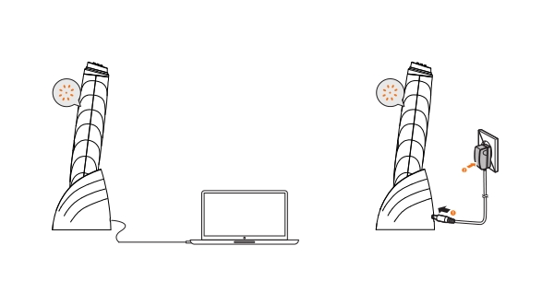
3.The indicator light is pulsing white when the tool is charging. It will be solid white when fully charged.

Notice:
Before charging make sure that the charging base and charging cable are dry and free of moisture and skincare products. Do not immerse in water. Please do not use the instrument while it is charging. Do not leave in charging base for more than 24 hours.

Cleaning the instrument
The following maintenance instructions are important to ensure the proper functioning of your tool. If these instructions are not followed, your tool may provide less than ideal skin care or the tool may stop working altogether.
Make sure your tool is powered off before starting cleaning.
When cleaning the tool body, wipe it with a dry cloth only. You may use an anti-bacterial wipe on the tip only.
Do not use steel wool, abrasive cleaners, or corrosive liquids such as alcohol or acetone to clean the instrument.
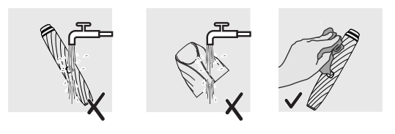
Thoroughly clean the tool after each use to ensure long term quality performance. Never rinse or soak your tool or charger in water. Make sure all parts are dry before reconnecting the charging cable.
1-YEAR LIMITED WARRANTY
The Eye and Lip Enhancer has a 1-year warranty from original date of purchase against manufacturer defect. If you discover a defect and notify us during the warranty period, we will replace the tool. The warranty covers working parts that affect the tools’ function. It does NOT cover purely cosmetic deterioration caused by wear and tear or damage caused by accident, misuse, or neglect. Any attempt to open the tool voids the warranty. For any warranty claim, reasonable evidence must be provided that the date of the claim is within the warranty period. Contact the person or company you purchased the tool from.
Environment: Do not throw away the tool with normal household waste at the end of its life. Hand it in for official recycling. By doing this, you help to preserve the environment.
Materials: ABS + Zine-alloy
Size: Tool-155*28*26 mm, Charger-62*55*59 mm
Weight: Tool-94g, Charger-67 g
Battery: Li-ion 450 mAh 3.7V
Charging Time: 2 hours
Usage: up to 40 minutes continual
Interface: 1-button
Disclaimer: Users of this tool do so at their own risk. Neither the manufacturer nor its retailers assume any responsibility or liability for any injuries, physical or otherwise, resulting directly or indirectly from the use of this tool.

